DYNAMIC SQL WITH DML STATEMENT

CREATE TABLE employees_names (

employee_id NUMBER PRIMARY KEY,

first_name VARCHAR2(50),

last_name VARCHAR2(50),

hire_date DATE,

job_title VARCHAR2(100)

);

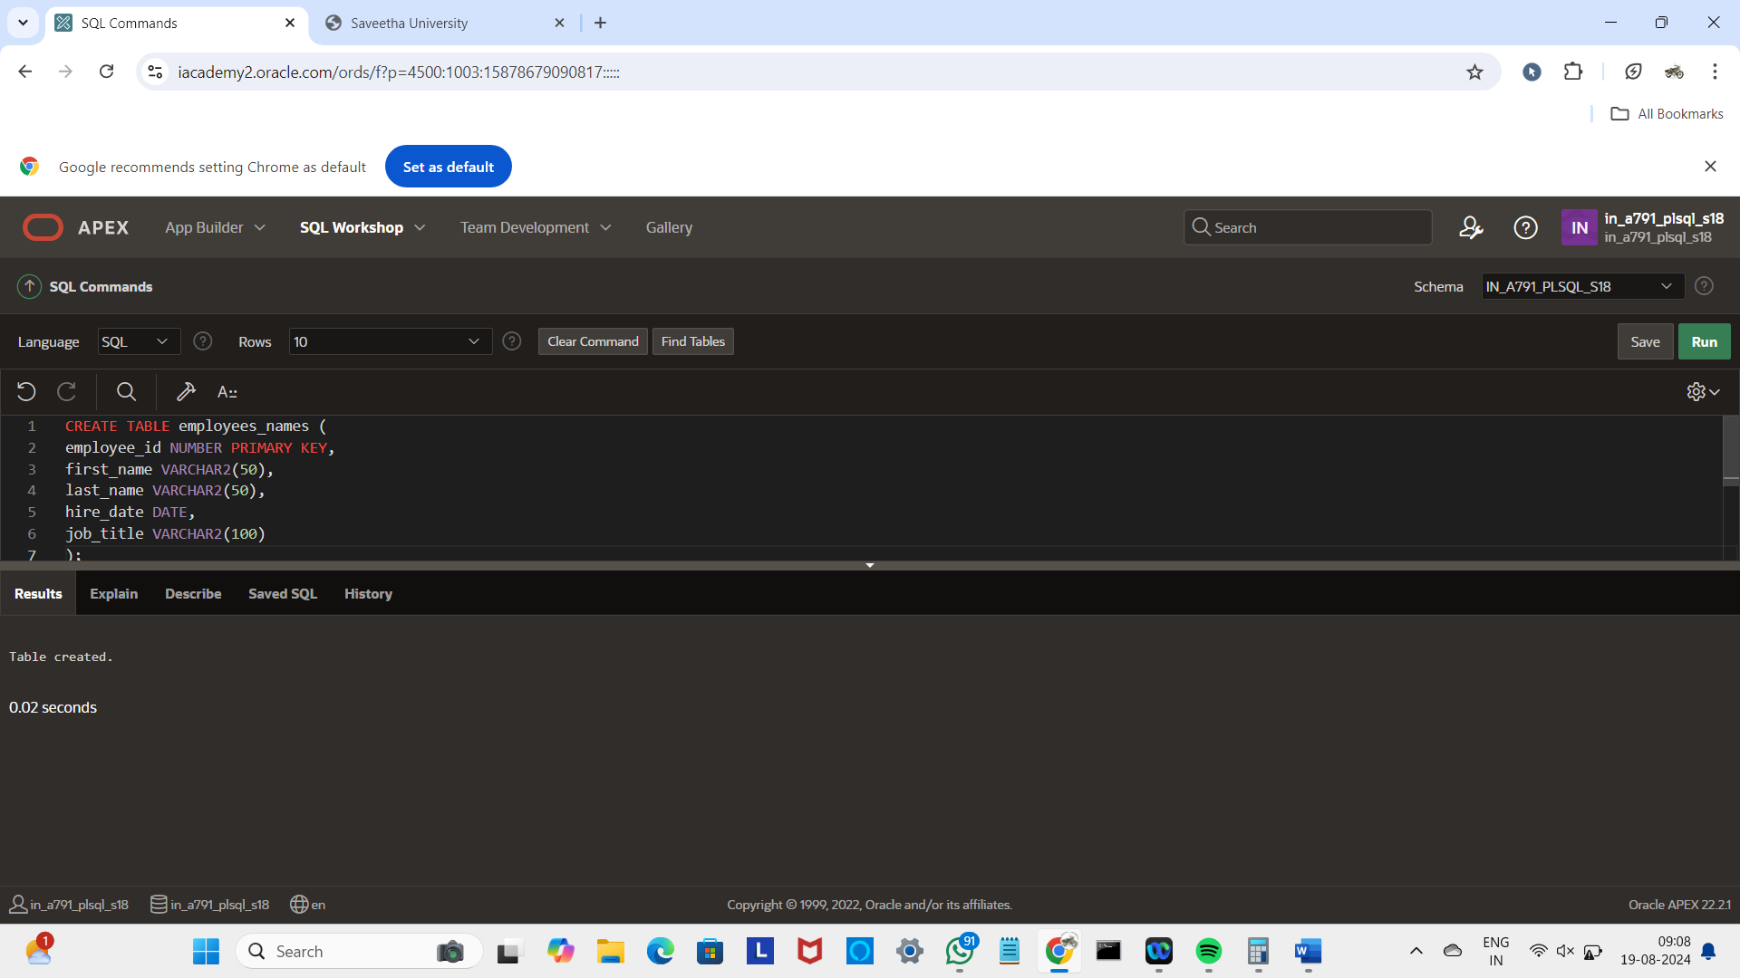

CREATE FUNCTION del_rows(p_table_name VARCHAR2)

RETURN NUMBER IS

BEGIN

EXECUTE IMMEDIATE 'DELETE FROM ' || p_table_name;

RETURN SQL%ROWCOUNT;

END;

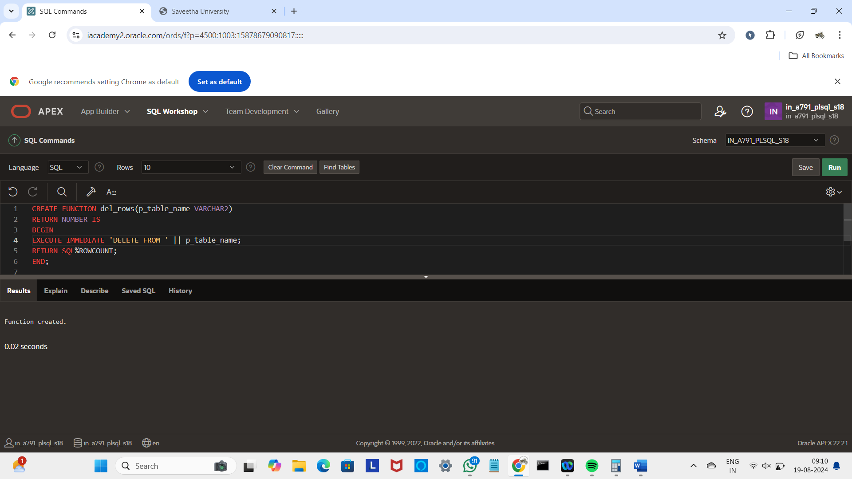

DECLARE

v_count NUMBER;

BEGIN

v_count := del_rows('employees_names');

DBMS_OUTPUT.PUT_LINE(v_count || ' rows deleted.');

END;

